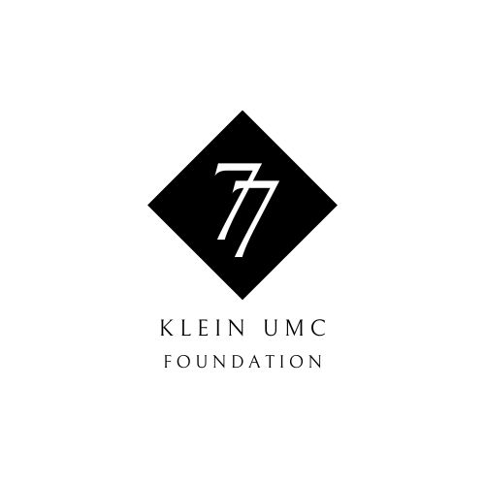**77 Society Gift Form**

**Gifts Paid by Check or On-Line Gift**

**STEP 1:** Please complete the donor information form below and submit with your check.

**STEP 2:** Please make check payable to Klein UMC Foundation

On the Memo Line, please note: TMF Acct. 56192

**STEP 3:** Please send check and completed donor information form to the following:

Klein UMC Foundation

c/o Klein United Methodist Church

Attn: Carol Davis ***Questions?***

5920 FM 2920 *Please contact Dana Croswhite at*

Spring, TX 77388 [*kfdcroswhite@gmail.com*](mailto:kfdcroswhite@gmail.com)

**Donor Details Date:** Click or tap to enter a date.

|  |  |
| --- | --- |
| Full Name: | Click or tap here to enter text. |
| Address: | Click or tap here to enter text. |
| Phone: | Click or tap here to enter text. |
| Email: | Click or tap here to enter text. |
| Total Pledged Gift Amount: | Click or tap here to enter text. |
| Current Gift Amount: | Click or tap here to enter text. |
| Check or On-Line Gift? | Check On-Line Gift  *Check No.:*Click or tap here to enter text. |
| Intended Payment Schedule: | One-Time Gift  Monthly  Quarterly  Semi-Annually  Other |
| Is this a gift from an IRA? * | YES  NO  ***\* Gifts from IRAs are Qualified Charitable Distributions (QCDs) and are NOT tax deductible.*** |

*Donors who make cumulative gifts of $1,000 or more will become members of the 77 Society. Additional gifts are not required to maintain membership but are encouraged. A letter of acknowledgement will be sent upon receipt of gift.*